Issue) (fixed)

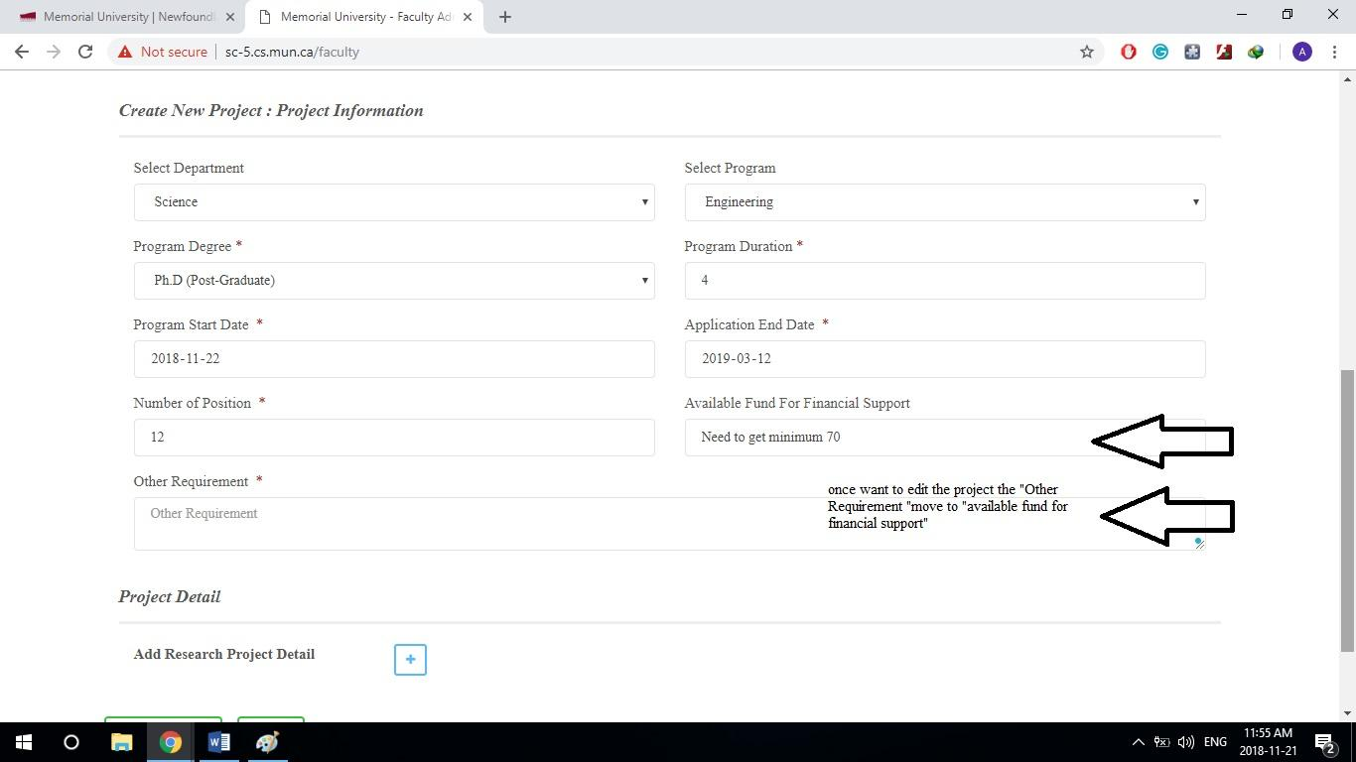

Explanation: any statement that saved in other requirement it was shifted to available fund. Need to se the fund just for integer numbers.

issue) (fixed)

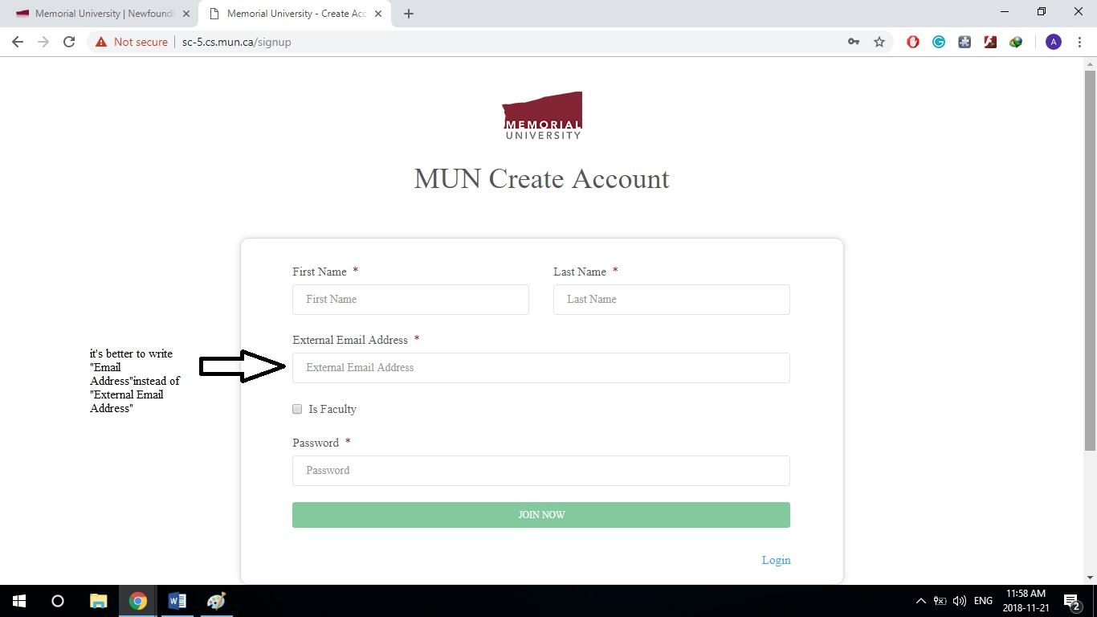

Explanation: just as a suggestion, it’s better to write Emil address only.

Issue) (fixed)

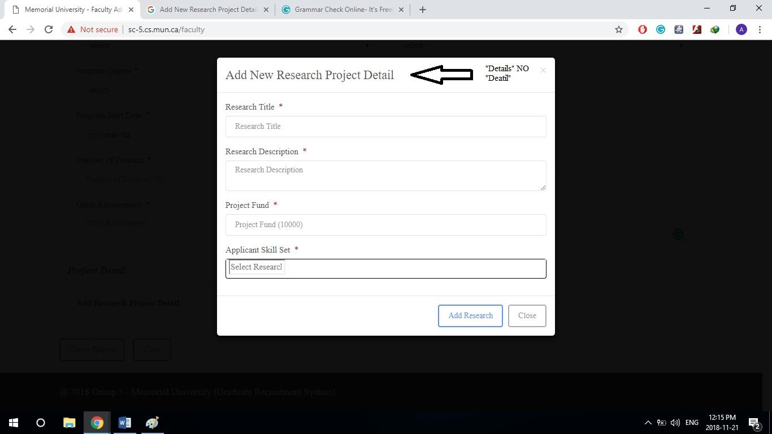

Issue) (fixed)

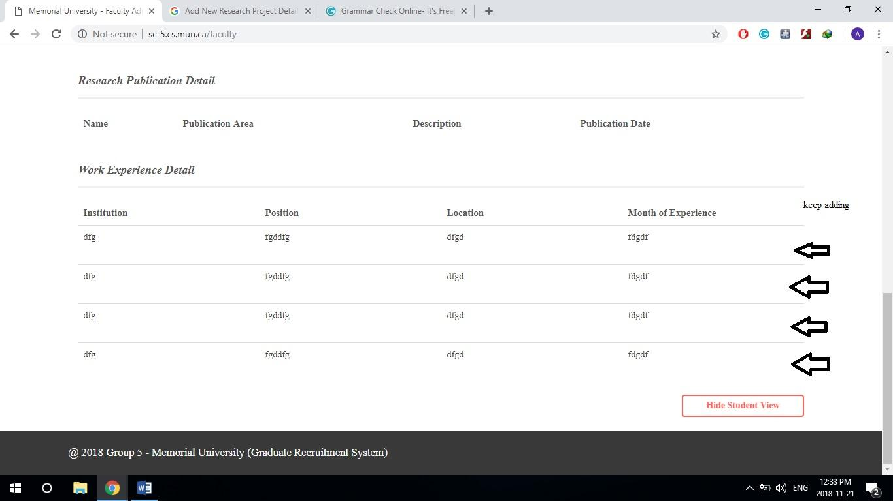

Explanation: any time press the view it will duplicate. Need to stop the sync.

Issue) (fixed)

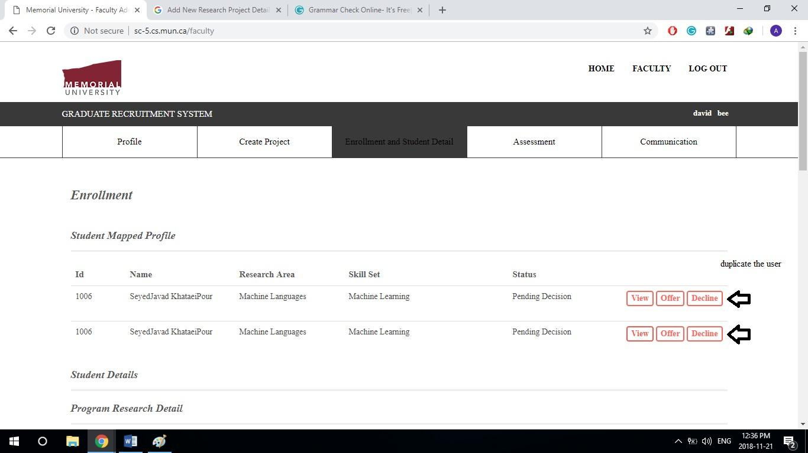

Explanation: Again is duplicating happend

Issue)